6 - Topbar
Topbar Introduction 8
File Menu 8
New 8
Open 8
Open Recent 8
Revert 8
Recover last Session 9
Recover Autosave 9
Save 9
Save As 9
Save Copy 9
Link 9
Append 9
Data Previews 9
Refresh Data-Block Previews 10
Batch Generate Previews 11
Clear Data-Block Previews 11
Batch Clear Previews 11
Import 11
Collada 11
Import Data Options 11
Import Units 11
Armature Options 11
Fix Leaf Bones 11
Find Bone Chains 11
Auto Connect 11
Minimum Chain Length 11
Keep Bind Info 12
Alembic 12
Manual Transform 12
Scale 12
Options 12
Set Frame Range 12
Is Sequence 12
Validate Meshes 12
FBX 12
Operator Presets 12
Main / Armatures 13
Main 13
Manual Orientation 13
Scale 13
!Experimental! Apply Transform 13
Import Normals 13
Import Animation 13
Animation Offset 13
Import User Properties 13
Import Enums as Strings 13
Image Search 13
Decal Offset 13
Use Pre/ Post Rotation 13
Armatures 14
Ignore Leaf Bones 14
Force Connect Children 14
Automatic Bone Orientation 14
Primary and secondary Bone Axis 14
Motion Capture (BVH) 14
Target 14
Scale 14
Start Frame 14
Scale FPS 14
Update Scene FPS 14
Update Scene Duration 14
Loop 14
Rotation 15
Forward 15
Up 15
Stanford (PLY) 15
Wavefront(OBJ) 15
Operator Presets 15
Smooth Groups 15
Lines 15
Split / Keep Vert Order 16
Split by Object 16
Split by Group 16
Keep Vert Order Poly Groups 16
Clamp Size 16
Forward 16
Up 16
Image Search 16
STL 16
Scale 16
Scene Unit 16
Facet Normals 16
Forward 16
Up 17
Scalable Vector Graphics (SVG) 17
glTF 2.0 (glb, gltf ) 17
Pack Images 17
Shading 17
Export 17
Collada 17
Operator Presets 17
Main 18
Selection Only 18
Include Children 18
Include Armatures 18
Include Shape Keys 18
Texture Options 18
Only Selected UV Map 18
Copy 18
Geom 18
Export Data Options 18
Apply Modifiers 18
Triangulate 18
Arm 19
Armature Options 19
Deform Bones only 19
Export to SL/OpenSim 19
Anim 19
Include Animations 19
Samples/Curves 19
Transformation Type 19
Keep Smooth Curve 19
Sampling Rate 19
Keep Keyframes 19
All Keyed Curves 19
Include all Actions 19
Extra 19
Collada Options 19
Use Object Instances 19
Use Blender Profile 20
Sort by Object Name 20
Keep Bind Info 20
Limit Precision 20
Alembic 20
Manual Transform 20
Scale 20
Scene Options 20
Start Frame 20
End Frame 20
Transform Samples 20
Geometry Samples 20
Shutter Open 20
Shutter Closed 20
Selected Objects only 21
Renderable Objects only 21
Visible Layers only 21
Flatten Hierarchy 21
Object Options 21
UV's 21
Pack UV Islands 21
Normals 21
Vertex Colors 21
Face Sets 21
Use Subdivision Schema 21
Apply Subsurf 21
Curves as Mesh 21
Triangulate 21
Quad Method 22
Polygon Method 22
Particle Systems 22
Export Hair 22
Export Particles 22
FBX 22
Operator Presets 22
Main 23
Selected Objects 23
Active Collection 23
Scale 23
Apply Unit Scale 23
Apply Scalings 23
Forward 23
Up 23
Empty / Camera / Lamp / Armature / Mesh / Other 23
!Experimental! Apply Transform 23
Custom Properties 23
Path Mode 23
Embed Textures 23
Batch Mode 23
Geometries 24
Apply Modifiers 24
Use Modifieres Render Settings 24
Smoothing 24
Loose Edges 24
Tangent Space 24
Armatures 24
Only Deform Bones 24
Add Leaf Bones 24
Primary Bone Axis 24
Secondary Bone Axis 24
Armature FBX Node Type 24
Animation 25
Baked Animation 25
Key all Bones 25
NLA Strips 25
All Actions 25
Force Start/ End Keying 25
Sampling Rate 25
Simplify 25
BVH 25
Scale 25
Start Frame 25
End Frame 25
Rotation 25
Root Translation Only 26
Stanford (PLY) 26
Apply Modifiers 26
Normals 26
UV's 26
Vertex Colors 26
Forward 26
Up 26
Scale 26
Wavefront(OBJ) 26
Operator Presets 27
Selection Only 27
Animation 27
Apply Modifiers 27
Use Modifier Render Settings 27
Inlcude Edges 27
Smooth Groups 27
Bitflag Smooth Groups 27
Write Normals 27
Include UV's 27
Write Materials 27
Triangulate Faces 28
Write Nurbs 28
Polygroups 28
Objects as OBJ Objects 28
Objects as OBJ Groups 28
Material Groups 28
Keep Vertex Order 28
Scale 28
Path Mode 28
Forward 28
Up 28
STL 28
Selected Only 28
Scale 29
Scene Unit 29
Ascii 29
Apply Modifiers 29
Batch Mode 29
Forward 29
Up 29
glTF 2.0 (glb, gltf ) 29
Operator Presets 29
General 30
Format 30
Selected Only 30
Apply Modifiers 30
Y up 30
Custom Properties 30
Remember Export Settings 30
Copyright 30
Meshes 30
UV's 30
Normals 30
Tangents 30
Vertex Colors 30
Materials 30
Objects 31
Cameras 31
Punctual Lights 31
Animation 31
Use Current Frame 31
Animations 31
Limit to Playback Range 31
Sampling Rate 31
Always Sample Animations 31
Skinning 31
Bake Skinning Constraints 31
Include all Bone Influences 31
Shape Keys 31
Shape Key Normals 31
Shape Key Tangents 31
External Data 32
Automatically Pack into .blend 32
Pack All into .blend 32
Unpack packed files 32
Use Files in current Directory (create when necessary) 32
Write files to current directory (overwrite existing files) 33
Use files in original location (create when necessary) 33
Write files to original location(overwrite existing files) 33
Make All Paths Relative 33
Make all Paths Absolute 33
Report Missing Files 33
Find Missing Files 33
Quit 33
Edit Menu 33
Undo 34
Redo 34
Undo History 34
Repeat Last 34
Repeat History 34
Adjust Last Operation 34
Operator Search 35
Lock Object Modes 35
Application Templates 35
How to create a application template 35
Save Startup File 37
Load Factory Settings 37
Preferences 37
Render Menu 37
Render Image 37
Render Animation 37
Mixdown Audio 37
OpenGL Render Image 37
OpenGL Render Animation 37
Open GL Render Options 38
Show / Hide Render 38
Play rendered Animation 38
Display Mode 38
Lock Interface 38
Window Menu 38
New Window 38
New Main Window 38
Toggle Window Fullscreen 38
Next Workspace 38
Previous Workspace 38
Show Top Bar 38
Show Status Bar 39
Save Screenshot 39
Toggle System Console 39
Help Menu 39
Manual 39
Release Note 39
Bforartists Website 39
Quickstart Learning Videos 39
Report a Bug 39
Blender Python API reference 39
Save System Info 39
Splash Screen 40
Navigation Tabs 40
Adding a new tab 40
Rename a tab 40

Topbar Introduction

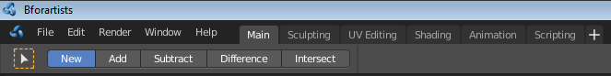

The Topbar is the area at the top that is visible in all workspaces. The topbar contains some general menus like File and Edit. It contains tabs to switch between workspaces. And it contains the tool area. This area displays options and settings for the currently active tool. In our shot the Box select tool is active. And so it shows some further settings for Box Select.
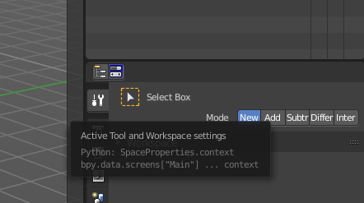
The tool area is a duplicate to the Active Tool and Workspace settings in the Properties editor, and shows the same tools. What is usually missing in the tool area is the labels.

Tool settings will be explained at a tool by tool case in the other chapters.

File Menu
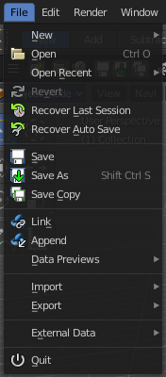
The File menu contains file related functionality.

New
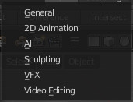
New is a sub menu. Here you can choose to create a new file with predefined Application Templates.
Application templates is a collection of workspaces for a predefined purpose.

Open
Open a blend file.

Open Recent
Open last recent blend files.

Revert
Reload the last saved file.

Recover last Session
Open the last closed blend file. (quit.blend)

Recover Autosave
Open the last autosaved blend file.

Save
Save blend file.

Save As
Save blend file as.

Save Copy
Saves a copy of the current file.

Link
Link allows you to link content from another blend file. The content remains in the other blend file. The linked blend file will be required to work with the linked content.

Append
Append allows you to append content from another blend file. The content will be copied over, and become part of the current blend file.

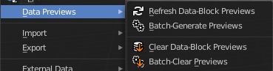
Data Previews
Data Previews is a sub menu with functionality around the Data Preview in the Bforartists file browser. The functionality in this menu creates and handles previews of the objects in a blend file.
Data Previews are displayed in the file browser when you link or append something from this file and when you use thumbnails as display method. It is meant for the case when you want to turn a blend file into a asset library. Materials, ready textured objects, etc. .
This feature is currently broken. You can't create data previews yet in Bforartists 2. Example images taken from Bforartists 1.
Workflow:
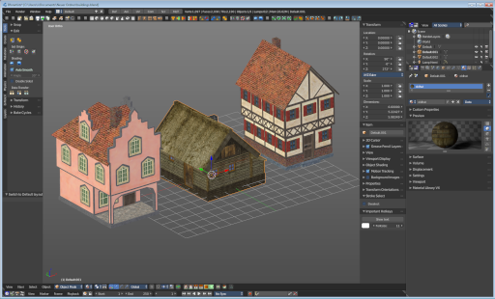
First create a scene with your assets. Make sure to remove the camera from the scene. It can work, but it can also make trouble, and prevent the batch generation to work at the blend file. And a asset library doesn't need a camera anyways. Not so important is lights, it does not make trouble like the camera. But you won't get a data preview icon for lights.
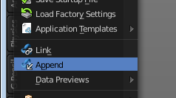
Save the scene. Restart Bforartists or create at least a new scene. We want to have a look what we currently get as preview when we want to link or append from this blend file. Make sure to turn the view in the file browser to thumbnails. It's always just the default icon for the assets. Left Materials, right the Objects.

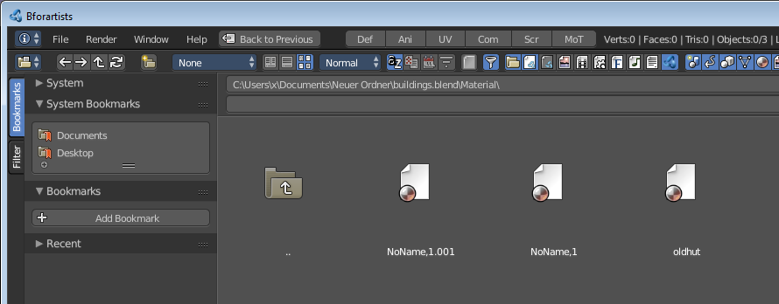
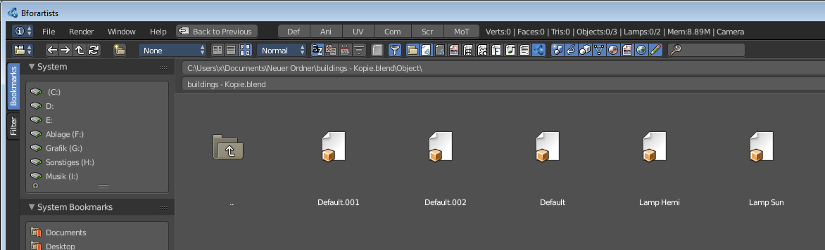

Now let's run Batch Generate Previews at this blend file.
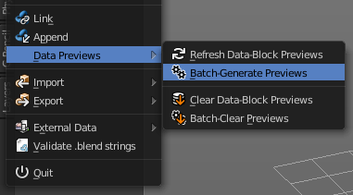
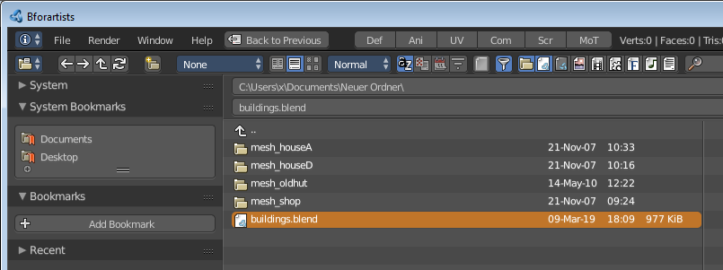

This process takes a while. Now let's try to append from the same file again. You will get proper preview thumbnails now. Left Materials, right the objects. Here you will see again that lamps have no preview icon.
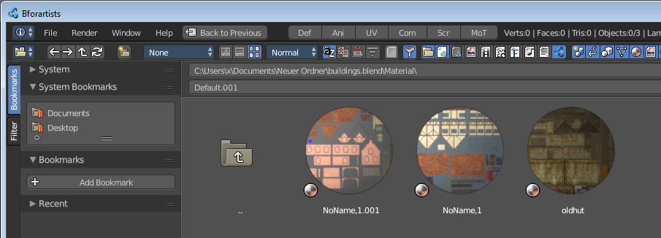
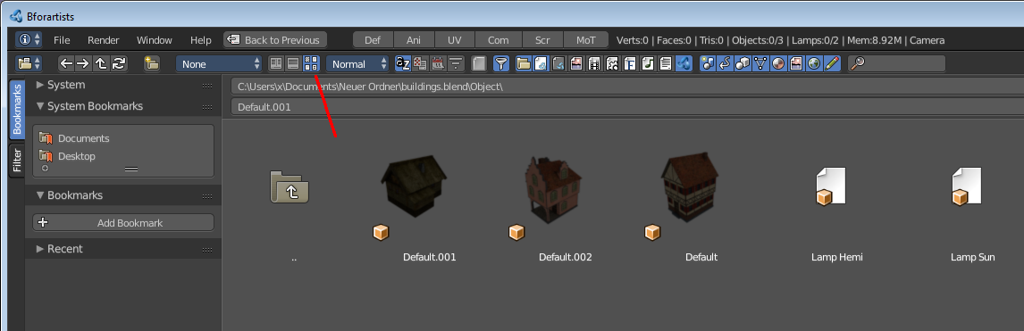

Refresh Data-Block Previews
Refreshes the existing data-block previews.

Batch Generate Previews
Generates the previews for the data objects in the selected blend file(s). The scene that you want to work at should not be loaded.

Clear Data-Block Previews
Removes existing previews for some types in the target blend file.

Batch Clear Previews
Removes all existing previews in the target blend file.

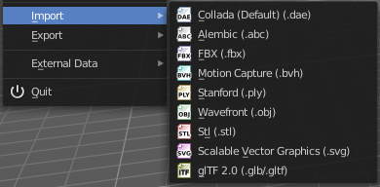
Import
Import is a sub menu with the available 3D import file formats. You will be prompted to the load dialog which provides some further import options down left in the file browser tool shelf.

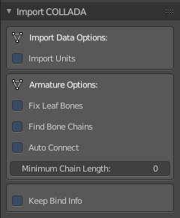
Collada
Imports a file in collada file format. Collada is a general file format that is able to store and load animation.

Import Data Options

Import Units
Imports the units that gots used to save the collada file . If unticked Blender Units will be used.

Armature Options

Fix Leaf Bones
Fix orientation of Leaf bones. Collada file formats only supports joints, not bones.

Find Bone Chains
Find best matching bone chains and ensure that the bones in the chain are connected.

Auto Connect
Auto connect parent bones that have exactly one child bone.

Minimum Chain Length
When searching bone chains disregard chains of length below this value.

Keep Bind Info
Store Bindpose Information in custom bone properties for later use in later collada export.

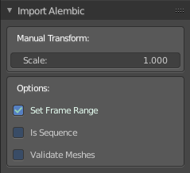
Alembic
The alembic file format is for static geometry. It does not support armatures, hair or particles.

Manual Transform

Scale
Here you can set the import scale factor.

Options

Set Frame Range
Sets the Frame range start and end point in Bforartists to match the one in the alembic file.

Is Sequence
Import sequenced files that are split in cache parts.

Validate Meshes
Check for invalid mesh data in the file. Note that this operation may take some time.

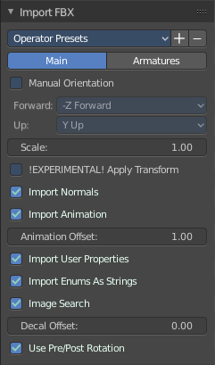
FBX
FBX is a proprietary file format from Autodesk. FBX is a general file format that is able to store and load animation.

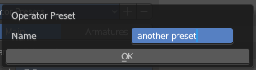
Operator Presets
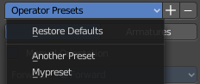
Here you can store and load presets. To add a preset, adjust the import dialog, click at the + button behind the dropdown box, add the name of the preset, and click OK. The preset will be stored automatically. To use the preset simply choose it in the dropdown box. Don't get irritated by that the dropdown box still shows "Operator Presets" when you choose your preset. The values of the chosen preset are set.
To remove a preset choose it in the dropdown box, and click at the - button behind the dropdown box. Also here, don't get irritated by that the dropdown box still shows "Operator Presets" . The chosen preset will be deleted.

Main / Armatures
The FBX import dialog has two tabs. Main and Armatures. In Main you will find the general import settings. In Armatures you will find armature related settings.

Main

Manual Orientation
Here you can choose to adjust a custom orientation to import your data. You can adjust the Forward and Up values to your needs.

Scale
Here you can adjust the scale factor at import.

!Experimental! Apply Transform
Bake space transform into object data. This avoids unwanted rotations when the target space is not aligned with the Bforartists space. Warning! This feature is experimental. Use at own risk.

Import Normals
Import Normals of the mesh.

Import Animation
Import animation.

Animation Offset
Here you can adjust a offset in frames for the imported animation.

Import User Properties
Import User properties as custom properties.

Import Enums as Strings
Stores enumeration values as strings.

Image Search
Search sub directions for associated images.

Decal Offset
Displace geometry of alpha meshes.

Use Pre/ Post Rotation
Use Pre or Post Rotation from FBX transform. This feature may not work in all cases.

Armatures

Ignore Leaf Bones
Ignore the last bone at the end of the chain.

Force Connect Children
Force connection of the children bones to their parent.

Automatic Bone Orientation
Try to align the mayor bone axis with the bone children.

Primary and secondary Bone Axis
Here you can manually adjust the bone orientation per axis. Note that this features are greyed out when Automatic Bone Orientation is ticked.

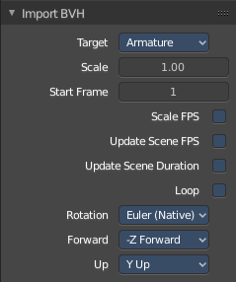
Motion Capture (BVH)
The Biovision Hierarchy (BVH) character animation file format is a file format to carry motion capture data.

Target
You can either target a armature or a object.

Scale
The import scale.

Start Frame
The start frame for the animation.

Scale FPS
Scale the framerate of the BVH file to the current scenes. With off every frame of the BVH is one frame in Bforartists.

Update Scene FPS
Sets the scene frame rate to that of the BVH file. Note that this nullifies the Scale FPS feature since the scale will be 1:1.

Update Scene Duration
Extend the scene duration to be the one of the BVH file duration.

Loop
Loop the animation playback.

Rotation
The rotation type.

Forward
The forward orientation.

Up
The Up orientation.

Stanford (PLY)
The Stanford Triangle Format was designed to store three-dimensional data from 3D scanners. It is a static file format for mesh data, and cannot carry animation data.
Stanford PLY has no import options.

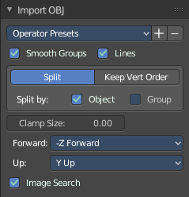
Wavefront(OBJ)
Wavefront Obj is a file format for static geometry. And while you can still create a sequence of meshes for animation with it (some software stores shapekeys that way for example), you cannot store animation in the file. It is also unique since it is usually made of two files. A OBJ part that contains the mesh data. And a MTL part that contains the material including the connected textures.

Operator Presets
Here you can store and load presets. To add a preset, adjust the import dialog, click at the + button behind the dropdown box, add the name of the preset, and click OK. The preset will be stored automatically. To use the preset simply choose it in the dropdown box. Don't get irritated by that the dropdown box still shows "Operator Presets" when you choose your preset. The values of the chosen preset are set.
To remove a preset choose it in the dropdown box, and click at the - button behind the dropdown box. Also here, don't get irritated by that the dropdown box still shows "Operator Presets" . The chosen preset will be deleted.

Smooth Groups
Surround smooth groups by sharp edges.

Lines
Import Lines and Faces with 2 verts as edge.

Split / Keep Vert Order
Split splits the mesh up. Keep Vertex Order imports everything as one mesh. Both methods have some further options.

Split by Object
Import loose meshparts as single objects.

Split by Group
Import Obj Groups as meshes.

Keep Vert Order Poly Groups
Import Obj groups as vertex groups.

Clamp Size
Clamp bounds under this value. A value of zero disables this feature.

Forward
The Forward orientation at import.

Up
The Up orientation at import.

Image Search
Search sub directions for associated images.

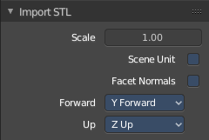
STL
STL (Standard Triangulation/Tesselation Language ) is a standard format for many cad software. It is a format for static geometry, it cannot handle animation. The format is popular for 3d printing purposes.

Scale
The import scale.

Scene Unit
Apply the scene unit at the geometry at import.

Facet Normals
Import the geometry with faceted faces.

Forward
The Forward orientation at import.

Up
The Up orientation at import.

Scalable Vector Graphics (SVG)
Scalable Vector Graphics is usually a 2D file format to describe vector graphics. But Vector graphics are also curves. Which can be used in a 3 dimensional space.
SVG has no import properties.

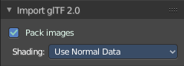
glTF 2.0 (glb, gltf )
The GL Transmission Format fron the Khronos Group is a file format for 3D scenes and models, and is based at the JSON standard.

Pack Images
Pack all images into the Blend file at loading the glTF file.

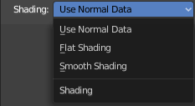
Shading
Here you can define the shading of the imported geometry.
Use Normal Data uses the existing normals.
Flat shading shades the whole mesh flat and facetted.
Smooth shading shades the whole mesh smooth.

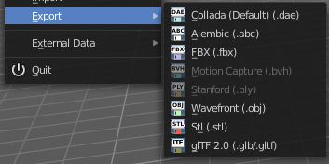
Export
Export is a sub menu with the available export formats.

Collada
Exports a file in collada file format. Collada is a general file format that is able to store and load animation.

Operator Presets
Here you can store and load presets. To add a preset, adjust the import dialog, click at the + button behind the dropdown box, add the name of the preset, and click OK. The preset will be stored automatically. To use the preset simply choose it in the dropdown box. Don't get irritated by that the dropdown box still shows "Operator Presets" when you choose your preset. The values of the chosen preset are set.
To remove a preset choose it in the dropdown box, and click at the - button behind the dropdown box. Also here, don't get irritated by that the dropdown box still shows "Operator Presets" . The chosen preset will be deleted.

The Collada exporter is divided into several subtabs since it would be too much to display all settings at once.

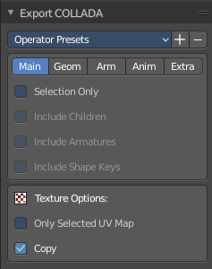
Main

Selection Only
Only export selected elements, not the whole scene.

Include Children
Export all children of selected objects, even if not selected.

Include Armatures
Export related armatures, even if not selected.

Include Shape Keys
Export all shape keys from Mesh Objects

Texture Options

Only Selected UV Map
Export only the selected UV map

Copy
Copy the textures to the same folder where the .dae file is exported.

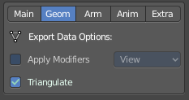
Geom
The geometry export section.

Export Data Options

Apply Modifiers
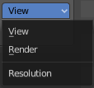
Applies the modifiers for export. The resolution can be adjusted in the dropdown box behind the Apply Modifiers checkbox. You can choose between View and Render.

Triangulate
Triangulates the mesh at export.

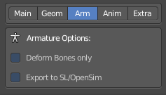
Arm
The armature export section.

Armature Options

Deform Bones only
Only export deforming bones with armatures.

Export to SL/OpenSim
Compatibility mode for SL, OpenSim and other compatible online worlds.

Anim
The Animation export section.

Include Animations
Export Animation if available.

Samples/Curves
Export samle keys or curves keys.

Transformation Type
The transformation type for translation, scale and rotation. Matrix or TransRotLoc.

Keep Smooth Curve
Just available with TransRotLoc transformation type. Export also the curve handles if available.

Sampling Rate
The distance between two keyframes.

Keep Keyframes
Use existing keyframes as sample points.

All Keyed Curves
Export also curves that has just one key or are completely flat.

Include all Actions
Export also unassigned actions.

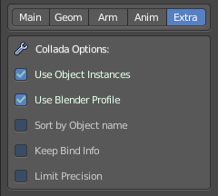
Extra
Some extra export settings.

Collada Options

Use Object Instances
Instantiate multiple objects from same data.

Use Blender Profile
Export Blender specific settings for shader, bones, materials, etc.

Sort by Object Name
Sort exported data by name.

Keep Bind Info
Store Bind Pose Information in custom bone properties for later use during Collada export.

Limit Precision
Reduce the precision of the exported data to 6 digits.

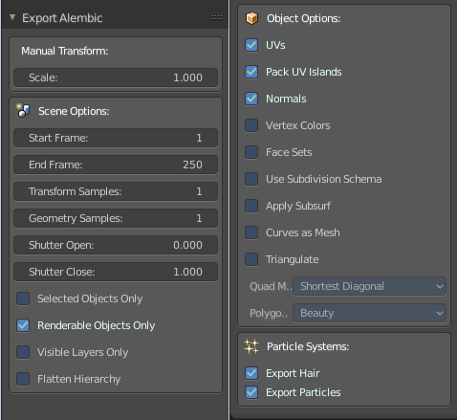
Alembic
The alembic file format is for static geometry. It does not support armatures, hair or particles. However, there are some options to export at least some data of it.
The alembic export options are divided into four sections.

Manual Transform

Scale
The export scale factor.

Scene Options

Start Frame
The start frame of the export.

End Frame
The end frame of the export.

Transform Samples
Number of times per frame at which animated transformations are sampled.

Geometry Samples
Number of times per frame at which geometry transformations are sampled.

Shutter Open
The start frame to sample transform and geometry samples. Valid range is -1 to 1. -1 indicates the previous frame, 0 indicates the current frame, and 1 indicates the next frame.

Shutter Closed
The end frame to sample transform and geometry samples. Valid range is -1 to 1. -1 indicates the previous frame, 0 indicates the current frame, and 1 indicates the next frame.

Selected Objects only
Export just selected objects.

Renderable Objects only
Export just renderable objects.

Visible Layers only
Export just objects in visible layers.

Flatten Hierarchy
Remove parent / children relationship.

Object Options

UV's
Export UV's. Note that Alembic just supports a single UV map.

Pack UV Islands
Export UV's with packed islands.

Normals
Export Normals.

Vertex Colors
Export Vertex Colors.

Face Sets
Export per Face shading group assignments.

Use Subdivision Schema
Export meshes using Alembic's subdivision schema.

Apply Subsurf
Export subdivision surfaces as meshes. Means apply subdivision modifier before export.

Curves as Mesh
Export Curces and Nurbs surfaces as meshes.

Triangulate
Triangulate meshes before export.

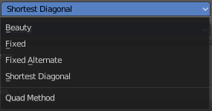
Quad Method
The quad method that gets used to triangulate the meshes.
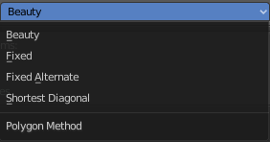

Polygon Method
The polygon method that gets used to triangulate the meshes.

Particle Systems
Alembic does not support hair or particles. However, here you can find some options to export at least some data of it.

Export Hair
Export hair particle systems as animated curves.

Export Particles
Export non-hair particles.

FBX
FBX is a proprietary file format from Autodesk. FBX is a general file format that is able to store and load animation.

Operator Presets
Here you can store and load presets. To add a preset, adjust the import dialog, click at the + button behind the dropdown box, add the name of the preset, and click OK. The preset will be stored automatically. To use the preset simply choose it in the dropdown box. Don't get irritated by that the dropdown box still shows "Operator Presets" when you choose your preset. The values of the chosen preset are set.
To remove a preset choose it in the dropdown box, and click at the - button behind the dropdown box. Also here, don't get irritated by that the dropdown box still shows "Operator Presets" . The chosen preset will be deleted.

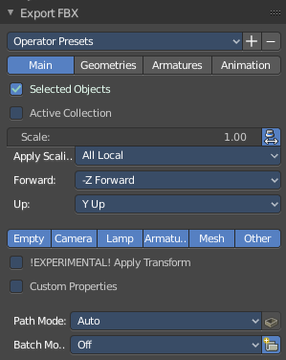
The FBX exporter is divided into several tabs since it would be too much to display all settings at once.

Main

Selected Objects
Export just selected objects.

Active Collection
Export just the active collection.

Scale
The scale factor for export.

Apply Unit Scale
Take the current Blender Units into account.

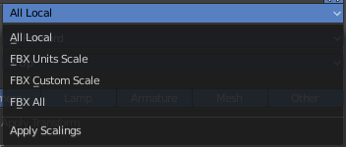
Apply Scalings
How to apply custom and unit scaling in the generated FBX file.

Forward
The forward orientation.

Up
The up orientation.

Empty / Camera / Lamp / Armature / Mesh / Other
What kind of object you want to export. Holding shift key adds to the current selection.

!Experimental! Apply Transform
Bake space transform into object data.

Custom Properties
Export custom properties if available.

Path Mode
Method used to reference paths.

Embed Textures
Just valid for method Copy. Embeds the textures into the FBX Binary.

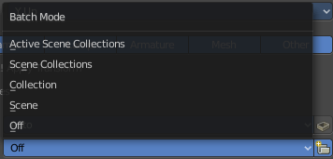
Batch Mode
Here you can adjust some further export methods. You can for example export every collection into a own FBX file.

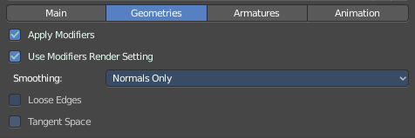
Geometries

Apply Modifiers
Apply existing modifiers before exporting.

Use Modifieres Render Settings
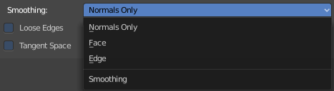
Use Render settings when applying modifiers. For example, the Subdivision Surface modifier has two independant setttings for the workspace and the rendering.

Smoothing
Define what smoothing information gets exported.

Loose Edges
Export loose edges. Loose edges are polygons with just two vertices.

Tangent Space
Add binormal and tangent vectors together with the tangent space information. This feature just works with tris or quads.

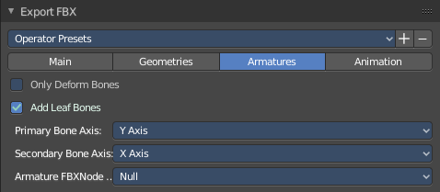
Armatures

Only Deform Bones
Only export deforming bones, and none deforming ones when they have children.

Add Leaf Bones
Add a final bone at the end of every bone chain.

Primary Bone Axis
The primary bone axis orientation.

Secondary Bone Axis
The secondary bone axis orientation.

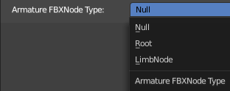
Armature FBX Node Type
FBX type of node used to represent a Blender Bone.

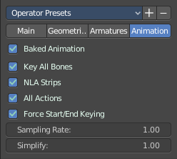
Animation

Baked Animation
Export baked keyframe animation.

Key all Bones
Force export at least one key of animation for all bones.

NLA Strips
Export each non muted NLA strip.

All Actions
Export each action as a separated FBX anim stack.

Force Start/ End Keying
Always add a keyframe at start and end of actions for animation channels.

Sampling Rate
How often to evaluate animated values, in frames.

Simplify
Here you can simplify the animation. 0.0 to disable. 1.0 does not simplify at all. Higher values simplifies the animation then.

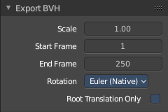
BVH
The Biovision Hierarchy (BVH) character animation file format is a file format to carry motion capture data.
To export BVH you need to have a armature with animation selected.

Scale
The scale factor for the export.

Start Frame
The start frame of the animation

End Frame
The end frame of the animation

Rotation
The rotation order that is defined in the BVH file.

Root Translation Only
Only write out translation values for the root bone.

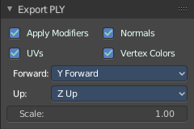
Stanford (PLY)
The Stanford Triangle Format was designed to store three-dimensional data from 3D scanners. It is a static file format for mesh data, and cannot carry animation data.

Apply Modifiers
Apply all modifiers before export.

Normals
Export normals.

UV's
Export UV's

Vertex Colors
Export Vertex Colors.

Forward
The forward orientation.

Up
The up orientation.

Scale
The scale factor for the export.

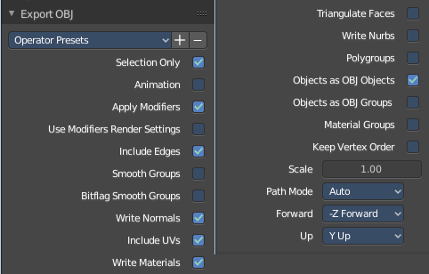
Wavefront(OBJ)
Wavefront Obj is a file format for static geometry. And while you can still create a sequence of meshes for animation with it (some software stores shapekeys that way for example), you cannot store animation in the file. It is also unique since it is usually made of two files. A OBJ part that contains the mesh data. And a MTL part that contains the material including the connected textures.

Operator Presets
Here you can store and load presets. To add a preset, adjust the import dialog, click at the + button behind the dropdown box, add the name of the preset, and click OK. The preset will be stored automatically. To use the preset simply choose it in the dropdown box. Don't get irritated by that the dropdown box still shows "Operator Presets" when you choose your preset. The values of the chosen preset are set.
To remove a preset choose it in the dropdown box, and click at the - button behind the dropdown box. Also here, don't get irritated by that the dropdown box still shows "Operator Presets" . The chosen preset will be deleted.

Selection Only
Export only the selected object(s).

Animation
Write out a Obj mesh for each frame.

Apply Modifiers
Apply Modifiers before export.

Use Modifier Render Settings
SDS modifier has a viewport and a render resolution. When ticked the render resolution gets chosen.

Inlcude Edges
Include loose edges at export. Loose edges are defined by two vertices only.

Smooth Groups
Write sharp edges as smooth groups.

Bitflag Smooth Groups
Write sharp edges as smooth groups, but generate smooth groups id's as bitflags.

Write Normals
Export Normals

Include UV's
Export UV's

Write Materials
Export materials. Note that the OBJ file format cannot carry the Blender material settings. The Obj file format uses a primitive Phong shader.

Triangulate Faces
Triangulate Faces at export.

Write Nurbs
Export Nurbs curves

Polygroups
Export Polygroups

Objects as OBJ Objects
Export objects as OBJ Objects.

Objects as OBJ Groups
Export objects as OBJ groups.

Material Groups
Export material groups.

Keep Vertex Order
Keep the vertex order at export.

Scale
The scale factor for the export.

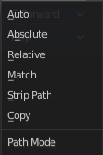
Path Mode
How the paths like texture paths gets handled at export.

Forward
The forward orientation.

Up
The up Orientation.

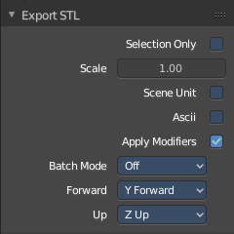
STL
STL (Standard Triangulation/Tesselation Language ) is a standard format for many cad software. It is a format for static geometry, it cannot handle animation. The format is popular for 3d printing purposes.

Selected Only
Export only the selected object(s).

Scale
The import scale.

Scene Unit
Apply the scene unit at the geometry at export.

Ascii
You can either export the file as binary format or as ascii format.

Apply Modifiers
Apply all modifiers before export.

Batch Mode
Export all geometry to one file or create a file for every object.

Forward
The Forward orientation at export.

Up
The Up orientation at export.

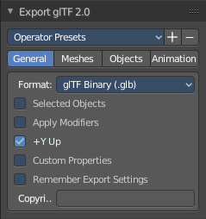
glTF 2.0 (glb, gltf )
The GL Transmission Format fron the Khronos Group is a file format for 3D scenes and models, and is based at the JSON standard.

Operator Presets
Here you can store and load presets. To add a preset, adjust the import dialog, click at the + button behind the dropdown box, add the name of the preset, and click OK. The preset will be stored automatically. To use the preset simply choose it in the dropdown box. Don't get irritated by that the dropdown box still shows "Operator Presets" when you choose your preset. The values of the chosen preset are set.
To remove a preset choose it in the dropdown box, and click at the - button behind the dropdown box. Also here, don't get irritated by that the dropdown box still shows "Operator Presets" . The chosen preset will be deleted.
glTF 2.0 exporter is divided into several tabs since it would be too much to display all settings at once.

General

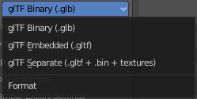
Format
Here you can choose between three export formats. Binary, Embedded and Separate.

Selected Only
Export only the selected object(s).

Apply Modifiers
Apply all modifiers before export.

Y up
Export with Y Up orientation.

Custom Properties
Export custom properties as glTF extras.

Remember Export Settings
Store glTF settings in the blender project. You need to save the project then.

Copyright
Here you can enter a custom copyright string.

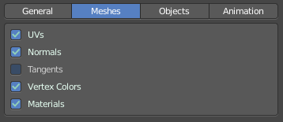
Meshes

UV's
Export UV's

Normals
Export Normals.

Tangents
Export Tangents.

Vertex Colors
Export Vertex Colors.

Materials
Export Materials.
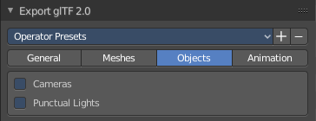

Objects

Cameras
Export Cameras.

Punctual Lights
Export Punctual Lights.

Animation

Use Current Frame
Export the scene in current animation frame.

Animations
Export active actions and NLA tracks.

Limit to Playback Range
Clips animations to selected playback range.

Sampling Rate
How often to evaluate animated values in frames

Always Sample Animations
Apply sampling to all animations.

Skinning
Export Skinning data.

Bake Skinning Constraints
Apply skinning constraints to armatures.

Include all Bone Influences
Allow vertex influences greater 4.

Shape Keys
Export Shape Keys. Also called Morph Targets.

Shape Key Normals
Export vertex normals with shape keys.

Shape Key Tangents
Export vertex tangents with shape keys.

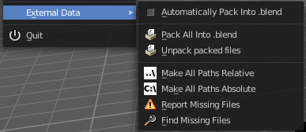
External Data
A Blend file may work with external data. Textures for example. Or text files. Or other Blend files, used as libraries.
In this menu you can adjust some settings for external data.
External data like textures or text files can also be packed directly into the blend file. This has some advantages, like that now all data is in one file. But also some drawbacks. Texture editing is for example not longer possible. You would have to export the texture first to be able to save the modifications.
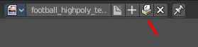
Packed data displays a packed icon in the dropdown box. This example is from the header of the UV editor. But you can see this icon also in the material editor at the texture node then.
Library Blend files cannot be packed. Use append instead of link to have the data of another blend file in the blend file.

Automatically Pack into .blend
Automatically pack all files into the blend file. Don't forget to save the blend file. Note that this greys out the two menu items Pack all into Blend and Unpack packed Files.

Pack All into .blend
Packs all external data into the blend file. Note that the paths must fit, and the external data must be available. A common pitfall here is that the textures uses absolute paths, and are moved to another location meanwhile. See Make all Paths Relative or Find missing Files. Or that you have a not longer existing file linked that shouldn't be in the blend file at all. See Outliner, Orphan Data.
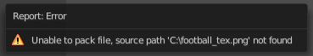
You will get a warning when something is missing.

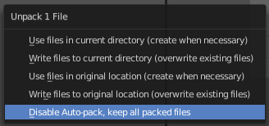
Unpack packed files
Unpack packed files exports all packed data. You will get an options menu where you can choose between several different unpack methods.

Use Files in current Directory (create when necessary)
Extracts all files to the current directory of the blend file. If the files in the current directory exists, reuse it. Else extract the ones from the blend file.
NOTE! The title is misleading, it does NOT write the files to the current directory. But into a subfolder, textures for example, in the current directory. Which gets created if necessary. And this option is not to change.

Write files to current directory (overwrite existing files)
Extracts all files to the current directory of the blend file, and writes it to the current directory. Existing content will be overwritten.
NOTE! The title is misleading, it does NOT write the files to the current directory. But into a subfolder, textures for example, in the current directory. Which gets created if necessary. And this option is not to change.

Use files in original location (create when necessary)
Extracts all files into their original directories where they were before packing them into the blend file. If the files in the original directory exists, reuse it. Else extract the ones from the blend file. This feature uses absolute paths.

Write files to original location(overwrite existing files)
Extracts all files into their original directories where they were before packing them into the blend file. If the files in the original directory exists, reuse it. Else extract the ones from the blend file. This feature uses absolute paths.

Make All Paths Relative
Make all paths relative means the path will be shortened to just the file name. For example, C:\myfolder\mysubfolder\mytexture.jpg turns into texture.jpg . Relative paths allows you to move the whole project folder to another location. The file paths will still be valid.

Make all Paths Absolute
Make all paths relative means the path will be shortened to just the file name. For example, turns into texture.jpg C:\myfolder\mysubfolder\mytexture.jpg. Absolute paths requires the full valid path for all files.

Report Missing Files
Scans through the blend file and tries to find missing files. You will get a warning when a missing file is found.

Find Missing Files
Browse for the new location of moved files.

Quit
Quit Bforartists.

Edit Menu
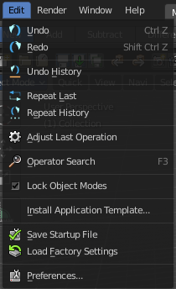

Undo
Reverts the last step.
Note. Bforartists uses two separated histories for the Object Mode and the Edit Mode. Means when you leave the Edit mode then you will loose the undo steps in the edit mode.

Redo
Rolls back your last Undo action.

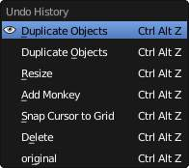
Undo History
The Undo History is a list of the last operations. Her you can roll back to a specific step.
Note that this Undo History is a session history, and does not save to the Blend file.

Repeat Last
Repeat last repeats the last operation. For example, when you have moved a object by 5 in X, then it moves the object by 5 in X with every repeat last step.

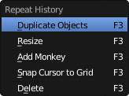
Repeat History
Repeat History calls a menu with the last actions where yon can choose an action to be repeated.

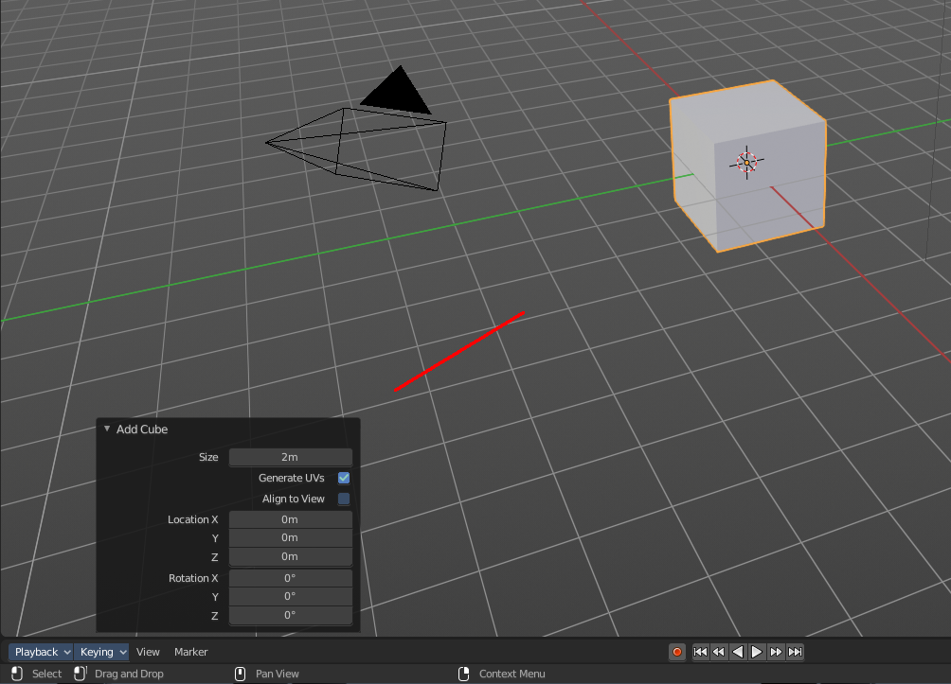
Adjust Last Operation
Some operations have settings, and can be further tweaked. It's the Blender ass forward concept for setting up a operation. In other software you set up an operation and perform it then with this settings. In Blender you first perform the operation, and tweak its settings afterwards. At least sometimes, this concept is not consistent. Bforartists is a fork of Blender. And so we have to live with this concept too.
For example, when you create a primitive, then you may want to adjust the size, or tick options like generate UV's at creation. This is done in the Last Operator panel. This Last Operator Panel is usually down left in the view.
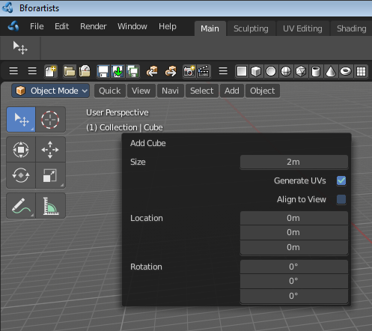
The Adjust Last Operation calls exactly this content as a menu popup.
Note that when you perform another operation, like moving the cube after creation, then the last operation content for creation is gone. It will now display the last operation content for the transform operation.

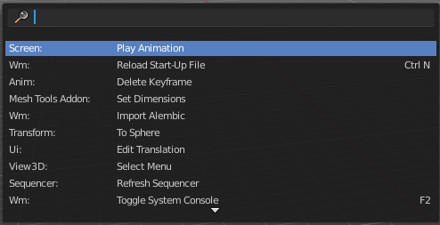
Operator Search
This menu item calls a search menu where you can search through all available operators, and perform them if needed. Think of it as one gigantic searchable dropdown menu that contains everything available.

Even operators that have no menu entries are listed. Which is useful for scripting purposes, when you want to perform a script operation, but don't have a menu button (yet).

You can navigate with the mouse or with arrow up and down buttons. Performing an operator can be done by clicking at it or by hitting enter.

Note that this search just lists the old traditional operators from before Blender 2.80. Not the ones in the Tool Shelf, which is a completely independant tool system.

Lock Object Modes
Restrict select to the current mode. For example, with this option off you may still accidentally select another object when you are in Edit mode.

Application Templates
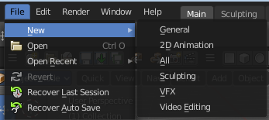
Here you can load a new application template.
Application templates is a predefined set of workspaces with its own setup. It can contain its own layout, theming, its own startup file, its own addon set and scripts, a own keymap and own lighting, and its own User Preferences.
Bforartists comes with six internal application templates already. Have a look at the "new" menu item in the file menu. Clicking at one of the menu items creates in fact a new scene by using one of the existing application templates.
Note that the whole application template system is buggy. And may not work!

How to create a application template
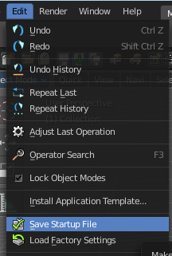
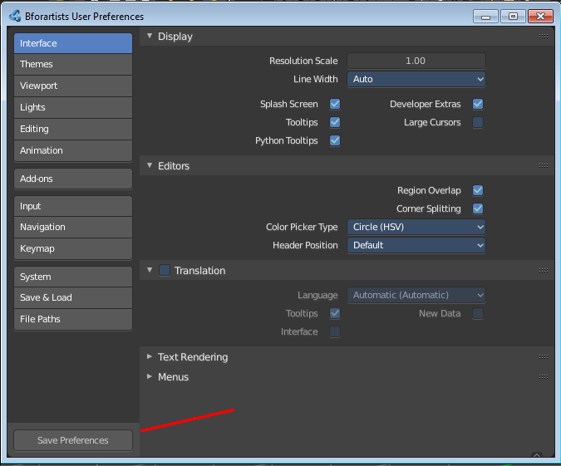
A application template is basically a zip file that contains a startup.blend, a userpref.blend, a splash.png and a __init__.py file that defines this all as a application template.
startup.blend and userpref.blend can be created in the Edit menu. Save startup file and User Preferences. So tweak everything to your needs, and save those two things.

At Windows you will find them in the appdata directory in the Bforartists folder.
At Linux it's in /home/yourusername/.config/bforartists/2.80/config/
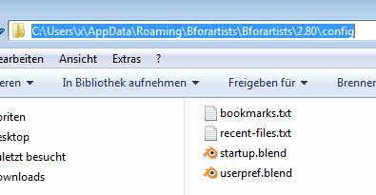
Copy those two files, startup.blend and userpref.blend, and throw them into a folder where you want to build the application template in. Rename this folder to AT_01, or to whatever name you want it to use.
Next create a png image as a splash screen for your template, and save it as splash.png into the AT_01 folder. The required size is 501x250. Everything else will throw an error, and you won't be able to see the new splash. You can alternatively also create a splashx2.png file in double size. This is for hidpi monitors.
The required __init__.py file is a python file with a def register and a def unregister.

def register():
print(Registering application template : {0}.format(__name__)
def unregister():
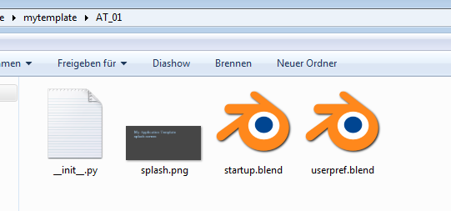
print(Unregistering application template : {0}.format(__name__)

So copy over this text, and save this file as __init__.py in the AT_01 folder
We should now have four files in the AT_01 folder. Zip the AT_01 folder. The template is finished for installing.
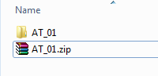
But as a last step, and before you install the template, remove the startup.blend and userpref.blend that we have created to build the application template from the config directory, to have a clean environment.
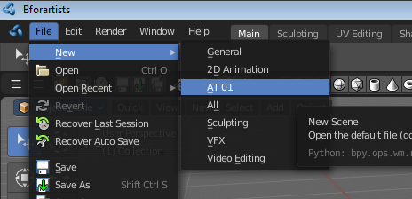
Once installed you will find the new application template in the New menu.
To remove an application template you need to remove its data in the config folder. There is no functionality to uninstall it.

Save Startup File
Saves a startup.blend with the current configuration.
A startup.blend stores layout informations. Editor layouts, default values, if a panel is open or closed, etc. .

Load Factory Settings
Resets Bforartists into a fresh installed state. All customer modifications, like activated addons, changes at the layout, etc. will be ignored.

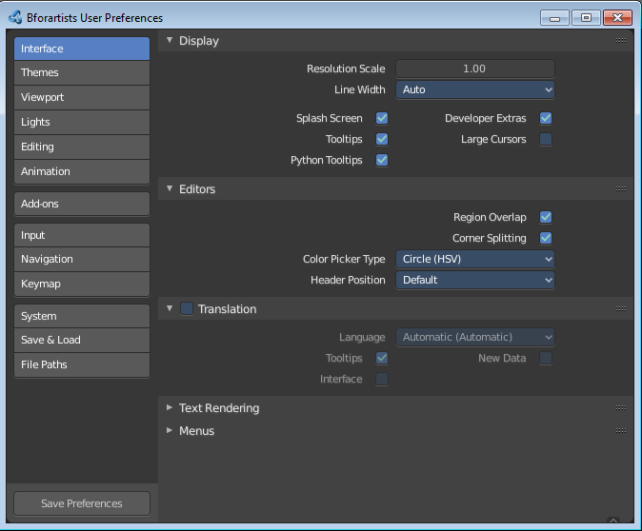
Preferences
Opens the Preferences window. Here you can adjust various settings.

Render Menu
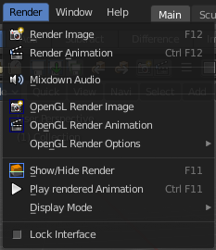
This menu contains functionality around rendering.

Render Image
Renders the current scene as an image by using the current chosen renderer.

Render Animation
Renders the current scene as an animation by using the current chosen renderer.

Mixdown Audio
Mixdown and export the scene's audio to an audio file. You will open an export dialog when you click at Mixdown Audio.

Options
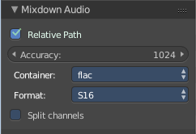
The options can be found downleft in the Save dialog.

Relative Path
Select the file relative to the blend-file.

Accuracy
Sample accuracy, important for animation data (the lower the value, the more accurate).

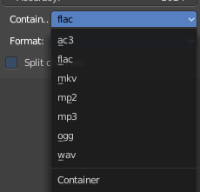
Containers
Here you can choose between different audio export formats.

Format
Some Audio Containers also have option to choose a codec. For more information see here.

Split Channels
Each audio channel will be rendered into a separate file.

OpenGL Render Image
Renders an Image, using the Viewport OpenGL renderer.

OpenGL Render Animation
Renders an animation, using the Viewport OpenGL renderer.
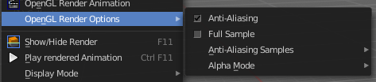

Open GL Render Options
Here you can adjust the look of the Open GL rendering.

Show / Hide Render
Toggles the display of the render view.

Play rendered Animation
Plays back the rendered animation sequence.

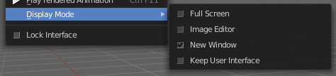
Display Mode
Here you can define how the render view gets displayed.

Lock Interface
Lock the interface during rendering in favour to give more memory to the rendering.

Window Menu
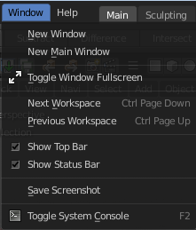
Window related functionality.

New Window
Creates a new instance of Bforartists. But without Top Bar.

New Main Window
Creates a new instance of Bforartists with its own workspace and scene settings and with the Top Bar.

Toggle Window Fullscreen
Makes Bforartists fullscreen.

Next Workspace
Cycle to next workspace.

Previous Workspace
Cycle to previous workspace.

Show Top Bar
Display the top bar.

Show Status Bar
Display the footer.

Save Screenshot
Saves a screenshot.

Toggle System Console
Toggles the System console. This is a Windows feature. Under Linux and Mac you can use the bash.

Help Menu

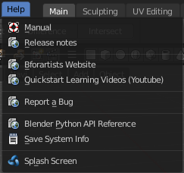
The Help menu contains some external links to useful resources. Here you can also find a utility to save the system information and to show the splash screen.

Manual
Opens the Bforartists Manual page in a web browser.

Release Note
Opens the Bforartists Release note page in a web browser.

Bforartists Website
Opens the Bforartists page in a web browser.

Quickstart Learning Videos
Opens the Bforartists Quickstart Youtube channel. Here you can find some learning videos.

Report a Bug
Here you can report a bug. The link leads you to Github. You need to create a Github account to be able to report a bug.

Blender Python API reference
Opens the Blender Python API reference page in a web browser.

Save System Info
Here you can save your system informations to a text file.

Splash Screen
Reveals the Splash Screen.

Navigation Tabs
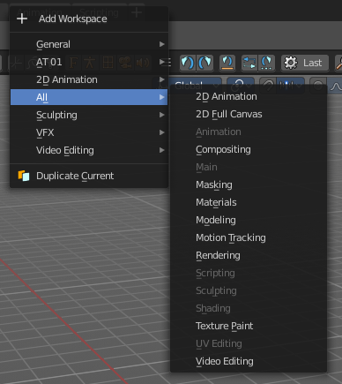
Application templates are a collection of Workspaces. Workspaces are a layout of screens and special setups. Like in what mode the workspace starts, how the windows are arranged and so on.

With the tabs you can switch between different workspaces of a application template.

Adding a new tab

You can also add a new workspace to the existing ones. For this you can either add one of the existing workspaces from the Add Workspace menu that hides under the + button at the right. The greyed out menu items are already added to the Tabs.

The other way is by duplicating the current workspace, tweak it to your needs, and rename it then. This can also be done in the Add Workspace menu. Duplicate Current.

When done, save the startup file to make the change permanent. Be careful here, this overwrites the current startup.blend file with all its settings.

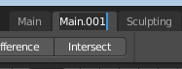
Rename a tab

To rename a tab double click at it. The name turns into a edit box then.

